NOVAC Technology Solutions



Business Requirement Document

For

SGI Philippines – All Product

Revision History

Version No. | Date | Reason For Changes | Author | Reviewer | Approver
Draft 135.1 | 22-10-2024 | Addition of salvage/Recovery column in claim paid report (INC ID : 55648) | M. Arunkumar | P.L.Nijanthan | Mr. Manoj Joseph
135.0 | 23-10-2024 | Baseline document of draft version 135.1 | M. Arunkumar | P.L.Nijanthan | Mr. Manoj Joseph

Table of Contents
1. Introduction 4
1.1. Purpose 4
1.2. Project scope 4
1.3. References 4
2. Functional Overview 4
2.1. Assumption and Dependencies 5
3. Interface Requirements 5
3.1. Internal Interfaces 5
3.1.1. Hardware Interface 5
3.1.2. Software Interface 5
3.1.3. Communication Interface 5
3.2. External Interfaces 5
3.2.1. Hardware Interface 5
3.2.2. Software Interface 5
3.2.3. Communication Interface 5
3.3. Operating Environment Requirement 5
3.3.1. Hardware Requirements 5
3.3.2. Software Requirements 5
3.3.3. Network Requirements 5
3.3.4. Operational scenarios 6
3.4. Non Functional Requirements (NFR) 6
3.4.1. Reliability 6
3.4.2. Performance 6
3.4.3. Security 6
3.4.4. Usability 6
3.4.5. Other Requirements 6
3.5. Open Issues 6
3.6. Acceptance Criteria 6
4. Appendix A 6

Introduction

Purpose
The purpose of this requirement is to add a new column for Salvage/Recovery column in Claims paid report. This is applicable for all Products.
  - Guidelines, circulars, instructions and directions released from time to time by Philippines Insurance council.

Project scope
To Add a new column in the Claims paid report.

References

Functional Overview
As per the change in requirement, a new column namely Salvage/recovery is to be added in the Claims paid report. (Excel attached in reference section)
During registration, if "Yes" is selected for claim recoverable/subrogation and any recovery type (Subrogation, Total Loss, or Salvage) is chosen, along with the corresponding recoverable amount, this amount can be collected through the Claim Recovery Report against the respective claim number.
The recoverable amount provided at registration will reflect against the claim record can be collected via receipt generation for the respective recovery. This collected value should be reflected in the claims paid report.
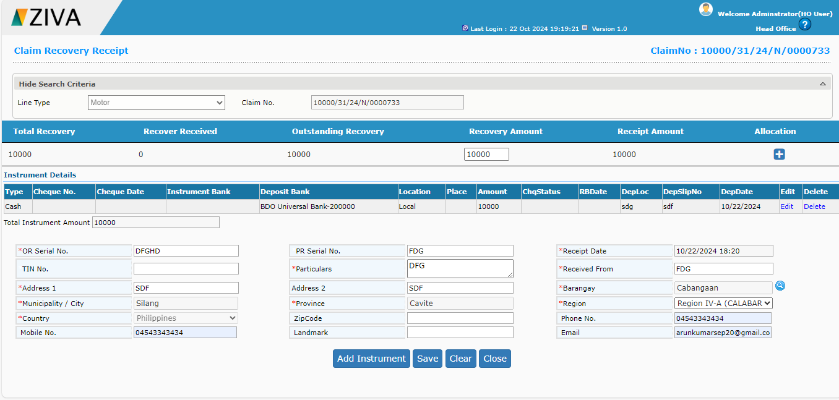

Assumption and Dependencies
<Not Applicable>

Interface Requirements

Internal Interfaces

Hardware Interface
<Not Applicable>

Software Interface
<Not Applicable>

Communication Interface
<Not Applicable>

External Interfaces

Hardware Interface
<Not Applicable>

Software Interface
<Not Applicable>

Communication Interface
<Not Applicable>

Operating Environment Requirement
<Not Applicable>

Hardware Requirements
<Not Applicable>

Software Requirements
<Not Applicable>

Network Requirements
<Not Applicable>

Operational scenarios
<Not Applicable>

Non Functional Requirements (NFR)

Reliability
<Not Applicable>

Performance
<Not Applicable>

Security
<Not Applicable>

Usability
<Not Applicable>

Other Requirements
<Not Applicable>

Open Issues
<Not Applicable>

Acceptance Criteria
- Functional testing will be executed by internal testing team, and the same will be delivered to client for UAT.

Appendix A
Not Applicable

